The American Flag
History
The first thirteen colonies declared independence from Great Britain in 1776. The Americans fought because they wanted self-government and freedom. On June 14, 1777, the United Stated adopted the first American flag. This day is called as Flag Day in the United States. The United States flag is a symbol of freedom and the men and women who have fought and died to protect it over the years.
Flag Day is a small holiday in the United States. Schools, banks and government offices remain open. On this day people fly flags in front of their homes and businesses to show their love of their country.
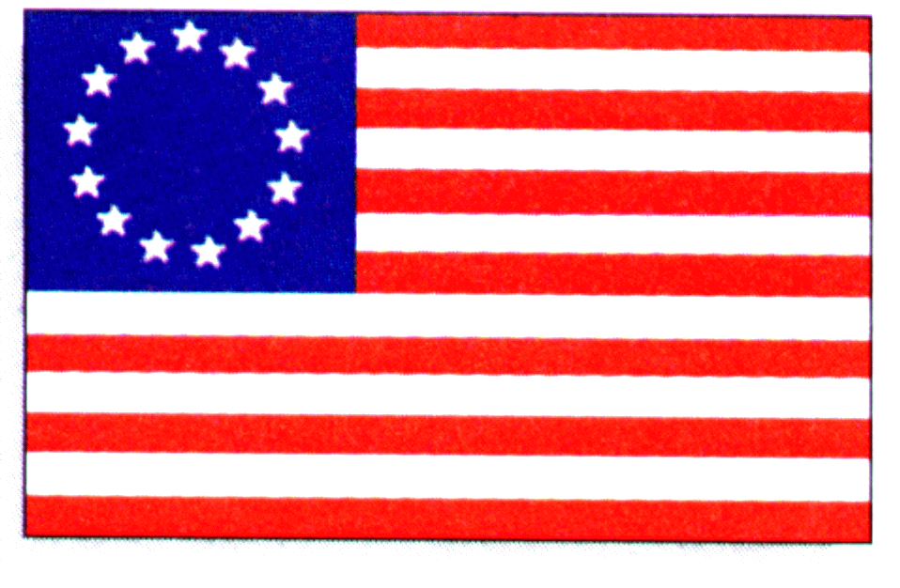
The First U.S. Flag
The first United States flag had 13 red and white stripes and a blue square with thirteen white stars. Over the years, the flag has changed 27 times as new states have been added.
Legend tells us that Betsy Ross made the first American Flag from a drawing that George Washington gave her. No one is sure if this story is true or not.
The U.S. flag is called several different names. The most popular ones are ‘Old Glory’, the ‘Stars and Stripes’, the ’Star-Spangled Banner”, and the ‘Red, White, and Blue.’
Meaning of the U.S. Flag
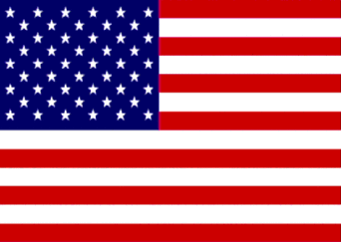
The American flag has three colors: red, white, and blue. White stands for having a pure heart and mind. Red stands for the blood (life) of the brave people who have fought for freedom. Blue stands for justice, and the “never give up”, “keep trying until you win” attitude. The 13 red and white stripes represent the first 13 states. Today there are fifty white stars in the blue square for the 50 states. If the United States adds another state, another star will be added to the flag.
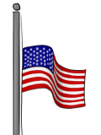
Rules for the U.S. Flag
- The flag should be raised (lifted up) in the morning and lowered (taken down) before sunset.
- The flag should always be lighted, either by sunlight or a light source.
- The flag should be flown in good weather.
- Never let the flag touch the ground.
- The flag is flown half way up the flagpole when a national leader or military member dies.
- A damaged flag is burned in a special ceremony.
- The flag is flown upside down only in an emergency.
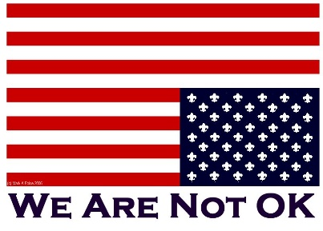

Adapted from: https://www.uscis.gov/citizenship/teachers/lesson-plans-and-activities
and http://www.ducksters.com/history/united_states_flag.php

Exercises: Work with 3-4 students from other countries to do the following exercises. The goal is to talk, listen, discuss and work together using English.

New Words: Read the definition first, then look for the matching word. Write the letter of the correct definition in the blank. Parts of speech: N=Noun, V = Verb, Adj. = Adjective, Adv. = Adverb

- Colony N
- Independence N
- Adopt V
- Stripe V
- Legend N
- Spangled Adj.
- Pure N
- Brave N
- Attitude N
- Blood N
- Symbol N
- Damaged Adj.
- Not mixed with anything else
- A traditional story with some truth
- To officially accept or approve
- A settlement in a new place
- Sign or representation of something
- The ability to make your own decisions
- Courageous
- Torn, hurt, spoiled, ruined
- Covered with stars
- A feeling or behavior
- A long line of color
- Not depending on others

Fill in the Blank: Write a new word in each blank. Use the correct form of the word.
- Sue and Tom ____________________ a baby girl.
- Jerry is a ____________________ soldier.
- A zebra has black and white _______________________.
- Having a positive ___________________ is important for success.
- Drinking __________________ water is good for your health.
- Young Mi ____________________ her car in an accident.
- Jamestown, Virginia was the first _____________________ in the U.S.
- Teenagers want their ______________________ from their parents.
- When Ty cut his finger, there was a lot of _____________________.
- A flag is a ___________________ its country.
- Many countries have experienced _____________________ in the 20th century.
- I love to read about American ___________________.
Write Sentences: Choose 5 new words and write a sentence with each one.
- __________________________________________________________________
- __________________________________________________________________
- __________________________________________________________________
- __________________________________________________________________
- __________________________________________________________________

Comprehension Questions: Fill in the blank with answers from this article.
* Questions on the U.S. Citizen Test.
- The United States adopted their first flag in the year __________.
- Flag Day is celebrated on ____________________ (date),
- __________________ __________________, the first president, drew a picture of the first flag.
- According to legend, __________________ __________________ made the first flag.
- * The colors of the U.S. flag are _____________, _____________, and _____________.
- * There are ____________________ stripes are on the U.S. flag.
- * The stripes symbolize the first thirteen ____________________ of the U.S.
- * The stars are ____________________ (color) on the U.S. flag.
- * The stars on the flag represent the ____________________ in the U.S.
- Today there are ______ stars on the U.S. flag.

Discussion Questions: * Questions on the U.S. Citizen Test.
- What are four other names for the U.S. flag?
- What do the colors red, white and blue stand for?
- Describe your flag. Explain what the colors, shapes, symbols and words mean.

